Report No. 11743

A350-1000F MDCLS Cargo Display Panel (CDP) Dataloader Software Requirement Specification

Module: | CDP DLSW SRS Module
Configuration Type:
Configuration: | Stream

ANCRA INTERNATIONAL, LLC
601 South Vincent Avenue
AZUSA, CA 91702

Ancra International LLC proprietary rights are included in the information disclosed herein. Recipient, by accepting this document, agrees that neither this document nor the information disclosed herein, nor any part thereof shall be reproduced or transferred to other documents or used or disclosed to others except as specifically authorized in writing by Ancra International LLC. Unpublished – all rights reserved under copyright laws.
© 2023 Ancra International LLC

Signature Page
Ancra Signatures
Prepared By: |  |  | 01/01/2023
 | Name here |  | Date
Checked By: |  |  | 01/01/2023
 | Name here |  | Date
Approved By: |  |  | 01/01/2023
 | Name here |  | Date

Customer Signature
Approved By: |  |  | 01/01/2023
 | Name here |  | Date
Approved By: |  |  | 01/01/2023
 | Name here |  | Date
Approved By: |  |  | 01/01/2023
 | Name here |  | Date

Revision Record
Rev.  Level | Rev.  Date | Prep.  By | Check.  By | Effected  Pages | Change  Description

Table of Contents
1 Scope 8
2 Referenced Documents 9
3 Acronyms & Initialism 11
4 Cargo Display Panel Overview 13
5 Hardware/Software Interfaces 13
5.1 Dataloader Interface 13
6 Overview 14
6.1 Software Overview 14
6.2 CDP Modes 15
6.3 CDP Dataloader 16
7 High-Level Requirements 17
7.1 Data Loading Application 18
7.2 CAN Message Formats 21
7.3 Dataloading Initialization Phase 24
7.4 Loading Phase 25
7.4.1 First Block Operation 27
7.4.2 Second block to last block operation 28
7.5 End of Dataloading phase 30
8 Requirements Traceability Matrix 33
9 Appendix A - DO-178C and Supplements Cross - Reference Matrix 35

List of Figures
Figure 1 - CDP CIRD in Requirement Hierarchy 9
Figure 2 - CDP Data loader Interfaces 14
Figure 3 - CDP Software Architecture 15
Figure 4 - CDP Modes 16
Figure 5 - Cargo Display Panel Dataloader 17

List of Tables
Table 1 - Project Documents 10
Table 2 - Industry Standards 10
Table 3 - Customer Documents 11
Table 4 - Acronyms 13
Table 5 - CDP SW PN 20
Table 6 - CAN Extended Arbitration ID Format 21
Table 7 - Payload information 22
Table 8 - NAK Error code 22
Table 9 - CAN Extended Arbitration ID Format for Upload data 23
Table 10 - Payload for Upload Data 23
Table 11 - CAN Extended Arbitration ID Format for WACK Message. 23
Table 12 - Payload for WACK Request 23
Table 13 - LRU_ID for different type of Request/Response 24
Table 14 - Cargo Display Panel CAN Bus connectivity and its SW FIN 25
Table 15 - CAN Extended Arbitration ID Format for Abort Dataloading 32
Table 16 - Payload information for Abort Request 32
Table 17 - Forward Requirement Traceability Matrix 34
Table 18 - Backward Requirement Traceability Matrix 35
Table 19 - DO-178C Cross Reference Matrix 36

Scope
This Software Requirement Specification (SRS) defines the high-level software requirement (HLR) required for certification of the Cargo Display Panel Data Loader Software Computer Software Configuration Item (CSCI) of Main Deck Cargo Loading System (MDCLS). Each HLR is tagged with a unique trace tag and bidirectional trace is provided between the HLR and the parent system level requirement that it was decomposed from.
This SRS also identifies derived requirements that do not directly trace to system requirement, but which are necessary to provide a complete description of all functions the software must provide. These derived requirements will be provided with justification for their existence in the SRS.
This document falls at Tier 3 of the requirement hierarchy,
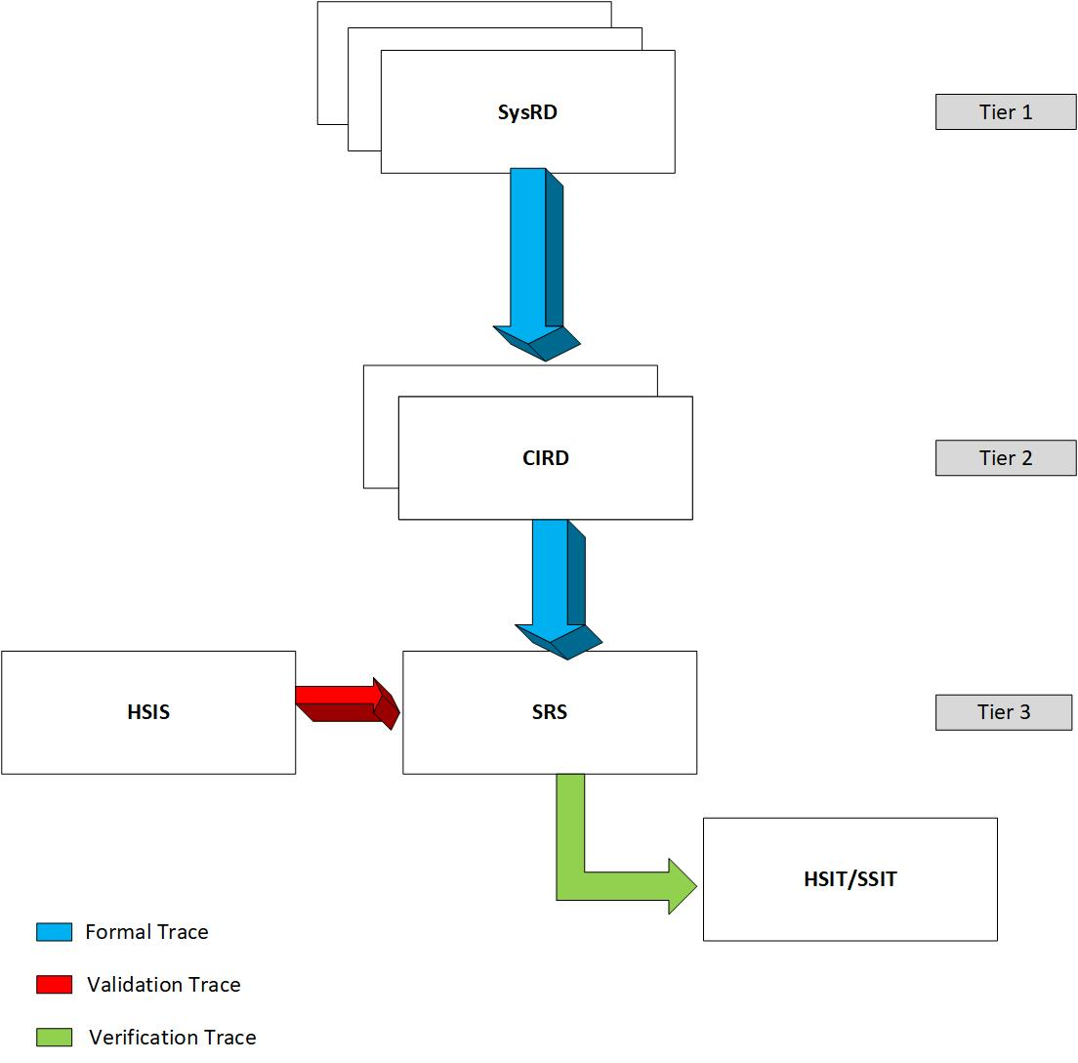
Figure 1 - CDP CIRD in Requirement Hierarchy

Referenced Documents
This section lists the project documents, customer documents, standards, procedures, government, and industry documents that are applicable to this document.
Document | Revision / Issue No | Title
11504 | B | Software Development Plan
11506 | B | Software and AEH Quality Assurance Plan
11507 | C | Software and AEH Configuration Management Plan
11508 | C | Software Requirements Standards
11595 | B | Interface Control Document for A350 Main Deck Cargo Loading System Electrical
11644 | D | Plan For Software Aspects of Certification A350-1000F MDCLS Cargo Display Panel software
11636 | B | CDP Configuration Item Requirements Document (CIRD) For A350-1000F MDCLS
11594 | D | Interface Control Document for A350 Main Deck Cargo Loading System Controller Area Network
11632 | C | System Requirement Document (SysRD)
11555 | D | System Configuration Index (SysCI)
11671 | B | Cargo Display Panel AEH Requirement Document
11672 | B | Cargo Display Panel AEH Software Interface Specification
11505 | C | Software Verification Plan
11904 | B | MDCLS Configuration Reporting and Dataload Specification
Table 1 - Project Documents
Document | Description
ED-12C/DO-178C | Software Considerations in Airborne Systems and Equipment Certification
Table 2 - Industry Standards
Document | Description
V5024PTSS21002  Issue: 2.0 | Main Deck Cargo Loading System (MDCLS) Purchaser Technical Specification
V42SP0806471  issue: 2.4 | CAN Dataloading Detailed functional Specifications
Table 3 - Customer Documents

Acronyms & Initialism
Acronym | Definition
ACK | Acknowledgement
ABD | Airbus Directive
AEH | Airborne Electronic Hardware
AFDX | Avionics Full Duplex Switched Ethernet
ALT | Alternative
ARINC | Aeronautical Radio Incorporated
CAN | Controller Area Network
CDP | Cargo Display Panel
CIRD | Configuration Item Requirement Document
CPIOM | Core Processing and Input / Output Module
CRC | Cyclic Redundancy Check
CRDC | Common Remote Data Concentrator
CSCI | Computer Software Configuration Item
DFS | Detailed Functional Specification
DL | Data Loader
DLA | Data Loader Application
DLSW | Data Loader Software
EEPROM | Electrically Erasable Programmable Read-only Memory
FID | Function Identifier
FIN | Functional Item Number
HLR | High Level Requirement
HSIT | Hardware Software Integration Testing
ICD | Interface Control Document
ID | Identification
IMA | Integrated Modular Avionics
LCC | Logical Communication Channel
LCL | Local
LRU | Line Replaceable Unit
MDCLS | Main Deck Cargo Loading System
NA | Not Applicable
NAK | No Acknowledgement
NVM | Non-volatile Memory
OPSW | Operational Software
PN | Part Number
PVT | Private
PTS | Purchaser Technical Specification
POST | Power On Self-Test
RAM | Random Access Memory
RCI | Redundancy Channel Identifier
RSD | Reserved
SRS | Software Requirement Specification
SW | Software
UI | User Interface
WACK | Wait Acknowledgement
Table 4 - Acronyms

Cargo Display Panel Overview
The Main Deck Cargo Loading System (MCDLS) includes a 17” Touch Screen Display called as Cargo Display Panel (CDP) to indicate System Status and support Maintenance Features. The Main page offers visualization of the System and provides information about the status of the individual components of the System. The Maintenance Page provides more detailed information about the status of the components of the System and allows the Operator to perform troubleshooting operations.
The Cargo Display Panel (CDP) is a monitoring device. CDP consists of a UI application hosted on a customized Linux Platform. CDP consists of a touch panel to display required monitoring information. CDP receives inputs of all LRUs and CPIOM via cRDC (A15) using CAN.
The UI application offers virtualization/visualization of the System and provides critical information about the Status of individual components of the System. The Cargo Display Panel will be installed in the sidewall lining LH-side of the aircraft. CDP receives the LRU status data over a CAN interface. The CDP software reads the CAN messages received in the CAN controller, processes the CAN message, validates it and updates the display with the respective visual indications thereby providing live data of all the operational data for each equipment.
CDP consists of an Electrical System. The CDP Hardware interfaces are defined in HSIS document (Rpt 11672).CDP is transmitting and receiving message to and from CPIOM via CRDC using CAN. Additionally, the CDP receives messages from other LRUs’ statuses, such as Control Panels and PDUs, via CRDC using CAN.
The Cargo Display Panel provides the visual indication for the following:
- PDU – Displays all the PDU status information and associated faults.
- Control Panel – Displays the status of all the buttons and switches present on all the Control Panels and associated faults.
- Cargo Zone – Displays the access Zone information associated with each control panel.

Hardware/Software Interfaces
Complete details of the HW components/interfaces of CDP are captured in Report 11672.

Dataloader Interface
The Dataloader software communicates over CAN interface to get the updated OPSW content. It uploads the updated Software to Actual Root Filesystem and runs the same. Similarly on reception of Dataload request, OPSW invokes Dataload Software.
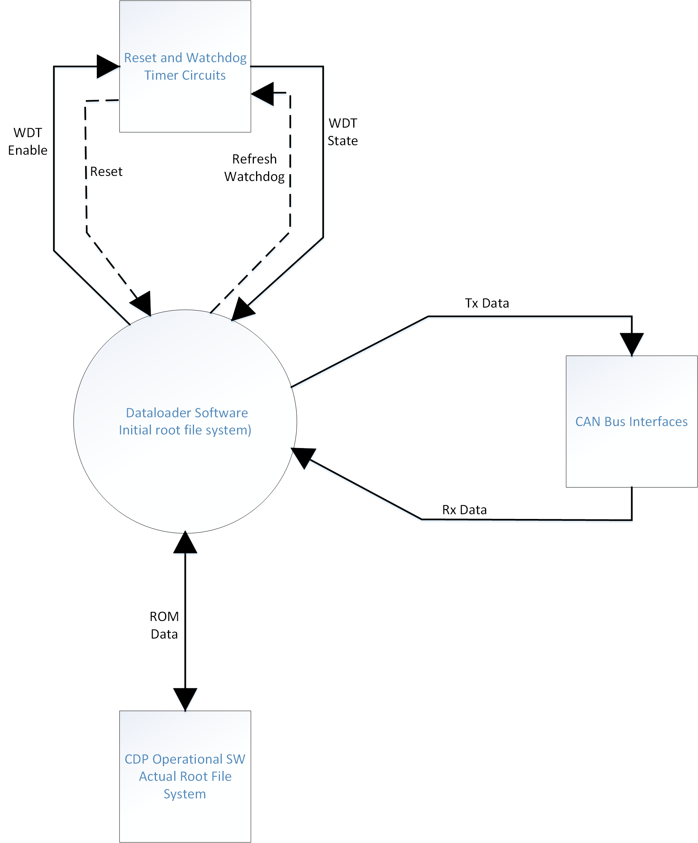
Figure 2 - CDP Data loader Interfaces

Overview

Software Overview
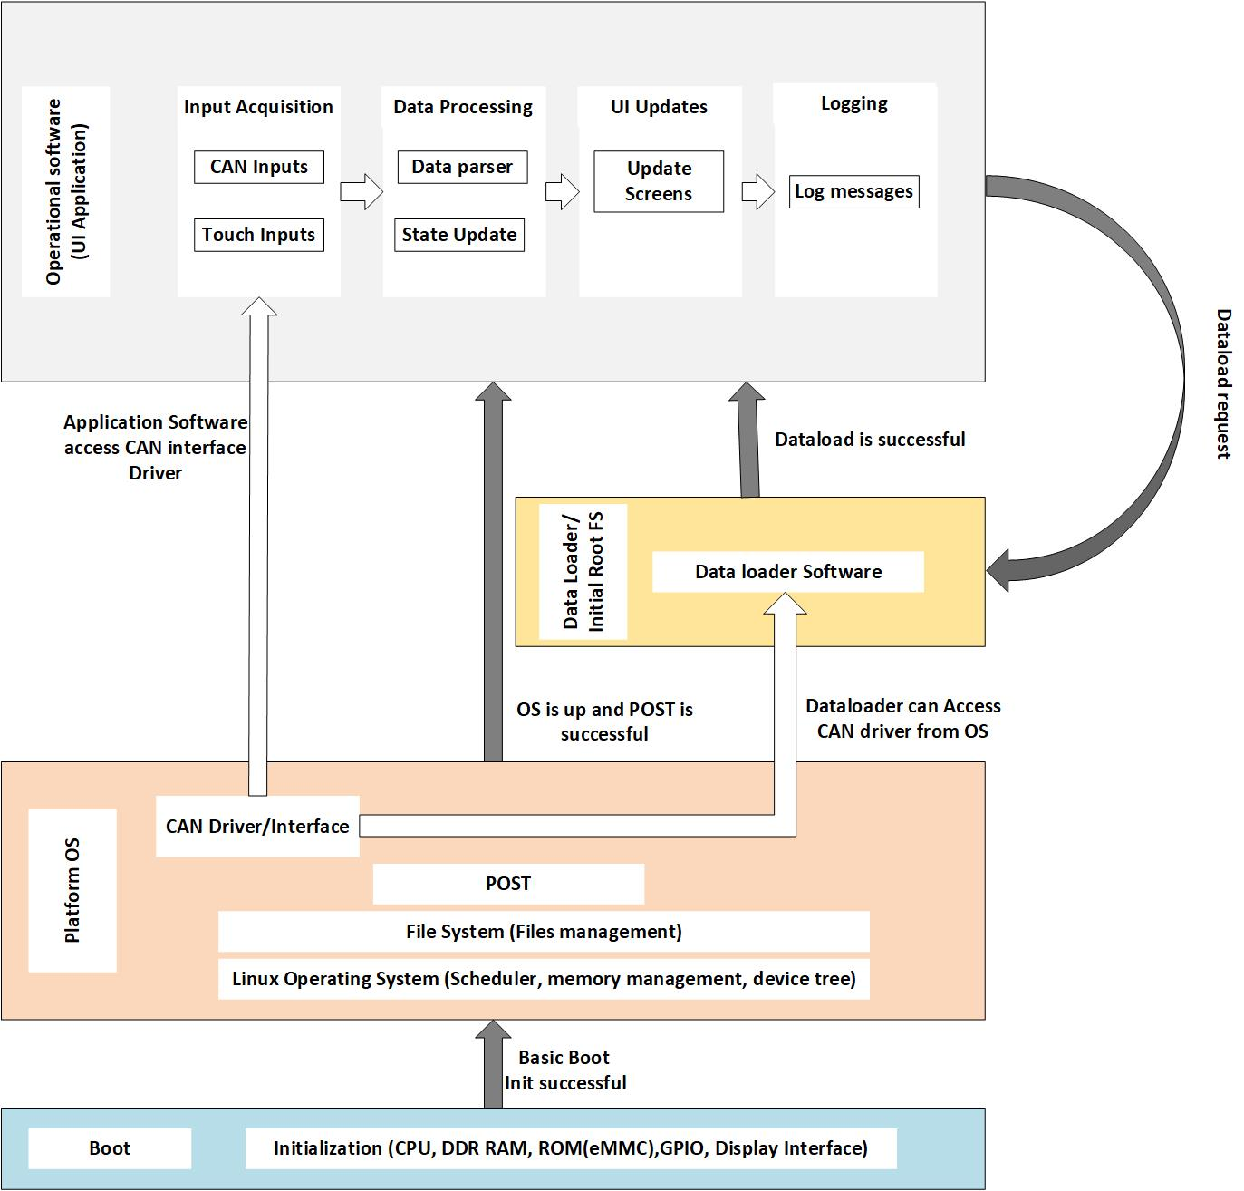
Figure 3 - CDP Software Architecture
CDP transitions from Bootloader to Platform Software after successful basic boot initialization. Platform software performs complete hardware initialization and transition to other CSCIs when valid conditions are met. POST runs from the Platform Software and checks for any Faults, if there are any faults it will log them. After POST is successful, CDP runs the Operational Software. On reception of a Dataload request, the Operational Software runs the Dataloader from the Initial root Filesystem. Dataloader, after a successful load operation starts the updated Operational Software from Actual Root Filesystem.

CDP Modes
The CDP operates in one of the following modes. CDP mode transitions are illustrated in the below figure:
- OFF Mode: The CDP is unpowered and the display is off.
- Initialization Mode: Initiated following the application of 28 VDC or at Power on Reset, initializes hardware, software and determines configuration.
- Live data Mode: The CDP enters Live Data Mode after successful initialization and continues to stay in this mode.
- Invalid Mode: The CDP enters Invalid Mode when the initialization is failed.
- Data Loading Mode: The CDP enters Data Loading Mode following the reception of Data load Request.
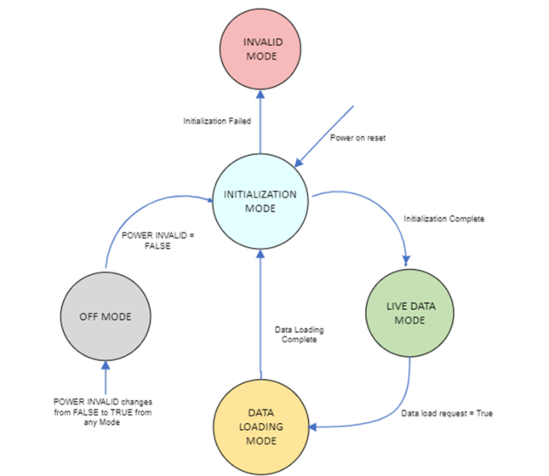
Figure 4 - CDP Modes

CDP Dataloader
The CDP Dataloader Software will use Dataloading Multicasting Protocol (DMP) to Dataload or Upgrade Operational Software in Cargo Display Panel. The communication between Data loader Application (DLA) residing in cRDC and CDP Dataloader Software is established via Controller Area Network (CAN) protocol defined in the CAN Interface Control Document (ICD), which is defined in the document "Rpt 11594".
The DLA will broadcast messages on a CAN Bus that multiple LRU which are connected on the same Bus can be data loaded simultaneously, the response from CDP Dataloader Software to DLA is transmitted as one-to-one communication via CAN Bus.
Multiple LRU: CRDC_A15 is connected to Inside Control Panel, Cargo Dispaly panel, PDUs etc....
Note: Brief information regarding DMP is explained in Section 7.
The following diagram shows the general architecture for Remote Data Loading using the CAN bus as a connection between CPIOM/cRDC and LRU.
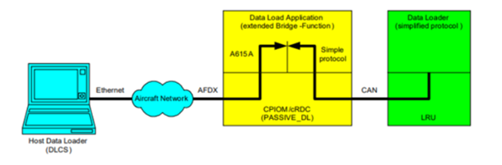
Figure 5 - Cargo Display Panel Dataloader
The requirements for Data loading of theCargo Display Panel using cRDC (ATA 42 resource) as a bridge between the AFDX network and the CAN bus are detailed in CAN Dataloading Detailed Functional Specification (V42SP0806471, Revision 2.4). Cargo Display Panel Data Loader software shall be implemented as per the LRU requirements detailed in the CAN DFS.
The CDP Dataloader software will load/ upgrade CDP Operational software on a target LRU with the help of DLS application through HOST based PC as explained in beginning of this section.
The CDP Dataloader Software consists of the following three phases:
- Dataloading Initialization Phase.
- Loading Phase.
- End of Dataloading phase.

High-Level Requirements
The Dataloading Multicasting Protocol is able to upload the software from the DLA (Dataloader Application) in a module (CPIOM/cRDC) to Cargo Display Panel Dataloader Software in CDP connected to the same CAN bus. The steps this protocol follows are enumerated here below:
1.Dataloading Initialization Phase,
2.Loading Phase,
3.End of Dataloading phase.
for more information Refer CAN_Dataloading DFS_v2.4
Information Regarding loadable Operational software,
1.Operational Software for Cargo Display Panel will be field loadable.
2.loadable binary file for the Cargo Display panel will be formatted according to ARINC 665-3 standard and V42SP0806471.
3.The size of the load data will strictly inferior to 4 Mega Bytes.
Terminologies used here,
ACK : Acknowledgement, NAK : NO Acknowledgement and WACK : wait Acknowledgement
muted CAN port: CDP Dataloader Software not send any CAN Message but receive the CAN Message,
Unmuted CAN port:CDP Dataloader Software send CAN Message also receive the CAN Message
Abort Dataloading:When a Dataloader software in DL mode aborts the dataloading process by itself it return to Operational Mode.
DL mode: when CDP Dataloader Receives Upload request with matching FIN number on its own, CDP DL enters into DL Mode then only it will accept upload data Message.
CDP DLSW not use the CAN port for any operation other than data loading function. Data loading function which transmission is send with Source FID as 42 in arbitration and reception is identified by Source FID as 42 in arbitration.
ID:CDP-DL-SRS-90249
The CDP Dataloader Software shall load the Field Loadable Software (FLS), i.e., Operational Software (OPSW) to the actual root file system.
Applicability: SW
Object Type: Derived
Rational for Derived Req:The Dataloader SW resides and is launched from the Actual Root File System.
Verification Method: HSIT
Safety Tag: true
Safety Impact: false
Safety Rationale: This is Derived Requirement. Failure of this requirement is not safety critical and is as per the Design assurance Level D.
LRU Applicability: CDP

Data Loading Application
ID:CDP-DL-SRS-109942
The CDP Dataloader shall provide a means to perform data loading of the Operational software using the CAN bus and protocol established by CAN ICD ("Rpt 11594")
Applicability: SW
Object Type: Verbatim
Verification Method: HSIT
Safety Tag: false
Safety Impact: false
LRU Applicability: CDP
ID:CDP-DL-SRS-112246
The CDP Data Loading operation shall not exceed 15 minutes.
Additional Information: Refer to the ABD0100 g2.1.4-324-A requirement.
Applicability: SW
Object Type: Verbatim
Verification Method: SSIT
Safety Tag: false
Safety Impact: false
LRU Applicability: CDP
ID:CDP-DL-SRS-112249
The CDP Operational Software shall be field loadable and formatted in accordance with ARINC 665-3 standard.
Applicability: SW
Object Type: Verbatim
Verification Method: Inspection
Safety Tag: false
Safety Impact: false
LRU Applicability: CDP
ID:CDP-DL-SRS-109943
The CDP Dataloader Software shall not use the CAN port for any other operation, during Data Loading Mode.
Additional Information: This is to improve data loading performance.
Note: Any other operation represents Live data mode or Initialization mode.
Applicability: SW
Object Type: Decomposed
Verification Method: HSIT
Safety Tag: false
Safety Impact: false
LRU Applicability: CDP
ID:CDP-DL-SRS-109944
The CDP Dataloader Software shall identify Loadable "Operational Software" by Software Part Number (SW PN) as per mentioned in the Table 5 below.
Applicability: SW
Object Type: Decomposed
Verification Method: HSIT
Safety Tag: false
Safety Impact: false
LRU Applicability: CDP
Software Identification | Software Part Number  (SW PN)
CDP Application Software | ANC2888153CDPSW
Table 5 - CDP SW PN
ID:CDP-DL-SRS-109950
The CDP Dataloader software shall comply with the requirements of V42SP0806471 and V4230RQ070272.
Additional Information:
1.V42SP0806471 describes the Detailed Functional Specification for CAN Data Loading (CAN DFS).
2.V4230RQ070272 describes CAN Detailed Functional Specification
Applicability: SW
Object Type: Decomposed
Verification Method: Analysis
Safety Tag: false
Safety Impact: false
LRU Applicability: CDP
ID:CDP-DL-SRS-110569
The CDP Dataloader Software shall receive Loadable "Operational Software" in data blocks.
Note 1: The Operational Software will be in Motorola S-record format. The Motorola S-record format comprises header information, file name, end-of-file marker, file size, and version details.
Note 2: First data block contains Field Loadable Software Header Information. Remaining data blocks contain Field Loadable Software.
Applicability: SW
Object Type: Derived
Rational for Derived Req:Data loader software receives "Operational Software" in Motorola S-record format. This information is not in CIRD. So This requirement is derived.
Verification Method: HSIT
Safety Tag: true
Safety Impact: true
Safety Rationale: Implementation of this requirement in Dataloader SW Level D has no safety risk involved.
LRU Applicability: CDP
ID:CDP-DL-SRS-113003
The CDP Data loader Software shall read the LRU ID from NVM memory for DMP.
Applicability: SW
Object Type: Decomposed
Verification Method: HSIT
Safety Tag: false
Safety Impact: false
LRU Applicability: CDP

CAN Message Formats
ID:CDP-DL-SRS-90820
The CDP Dataloader Software shall send CAN message with Extended 32-bit CAN Arbitration ID and 8 bytes of Payload for Dataloader ACK, NAK, WAIT and COMPLETE response to DLA as mentioned in Table-6, Table-7 and Table-8.
Applicability: SW
Object Type: Derived
Rational for Derived Req:Extended 32-bit CAN arbitration ID consist of LCC, Source FID, RSD, LCL, PVT, LRU_ID, ALT, TYPE, BLOCK_ORDER and RCI Fields. These fields will be unique for different kinds of Data loading operations such as Upload request, upload data and complete data load. So this requirement is derived to provide Extended 32-bit CAN arbitration ID from CAN DFS Document
Verification Method: HSIT
Safety Tag: true
Safety Impact: true
Safety Rationale: Implementation of this requirement as per CAN DFS, So there is no risk involved.
LRU Applicability: CDP
NA |  |  |  | LCC |  |  |  | Source FID |  |  |  |  |  |  |  | RSD |  | LCL |  | PVT |  | LRU ID |  |  |  |  |  |  | ALT |  | TYPE |  |  | NA |  | BLOCK ORDER |  |  |  | RCI
31 | 30 | 29 | 28 |  | 27 | 26 | 25 |  | 24 | 23 | 22 | 21 | 20 | 19 | 18 |  | 17 |  | 16 |  | 15 |  | 14 | 13 | 12 | 11 | 10 | 9 |  | 8 |  | 7 | 6 |  | 5 |  | 4 | 3 | 2 |  | 1 | 0
unused |  |  |  | 101 |  |  |  | 0101010 |  |  |  |  |  |  |  | 0 |  | 1 |  | 0 |  | LRU ID from NVM |  |  |  |  |  |  | 0 |  | 00 |  |  | 0 |  | 0000 |  |  |  | 00
Table 6 - CAN Extended Arbitration ID Format
Byte | Designation | Operation Range | Remarks
1 | Status | 0x15 = NAK  0x06 = ACK  0x57="W"=Wait  0x43="C"=Complete
2 | Error Code (If NAK)  Not used if ACK  Wait Value (if Wait)  Complete | see NAK Error Code  2-255 | In seconds
3 to 4 | Not Used |  | Reserved
5 to 8 | Free for System  application Use
Table 7 - Payload information
Designation | Value | Remarks
Not Used | 0 | Zero pads
Timeout Error | 2 | Bit 1 is set
Incompatible SW Version Load | 4 | Bit 2 is set
CAN Receiver Data Load | 8 | Bit 3 is set
Load Data Timeout | 16 | Bit 4 is set
Load Interlocks Failed | 32 | Bit 5 is set
CRC fail after programmed into Flash | 64 | Bit 6 is set
Table 8 - NAK Error code
ID:CDP-DL-SRS-90830
The CDP Dataloader Software shall receive CAN Messages with Extended 32-bit CAN Arbitration ID as mentioned in Table-9 and CAN payload with Load data blocks of [96-8160] bytes as mentioned in Table-10 for Upload Data from DLA.
Applicability: SW
Object Type: Derived
Rational for Derived Req:Implementation of this requirement as per CAN DFS, So there is no risk involved.
Verification Method: HSIT
Safety Tag: true
Safety Impact: true
Safety Rationale: This is Derived Requirement. Failure of this requirement is not safety critical and is as per the Design assurance Level D.
LRU Applicability: CDP
NA |  |  |  | LCC |  |  |  | Source FID |  |  |  |  |  |  |  | RSD |  | LCL |  | PVT |  | LRU ID |  |  |  |  |  |  | ALT |  | TYPE |  |  | NA |  | BLOCK ORDER |  |  |  | RCI
31 | 30 | 29 | 28 |  | 27 | 26 | 25 |  | 24 | 23 | 22 | 21 | 20 | 19 | 18 |  | 17 |  | 16 |  | 15 |  | 14 | 13 | 12 | 11 | 10 | 9 |  | 8 |  | 7 | 6 |  | 5 |  | 4 | 3 | 2 |  | 1 | 0
unused |  |  |  | 101 |  |  |  | 0101010 |  |  |  |  |  |  |  | 0 |  | 1 |  | 1 |  | 000000 |  |  |  |  |  |  | 0 |  | 11 |  |  | 0 |  | 0001-1100 |  |  |  | 00
Table 9 - CAN Extended Arbitration ID Format for Upload data
DL Request | Byte1 | Byte2 | Byte3 | Byte4 | Byte5 | Byte6 | Byte7 | Byte8
Upload Data | Load data blocks of [96-8160] bytes (in multiples of 96), padding the final data block with 0x00.
Table 10 - Payload for Upload Data
ID:CDP-DL-SRS-90847
The CDP Dataloader Software shall receive CAN Messages with Extended 32-bit CAN Arbitration ID as mentioned in Table-11 and CAN payload with 2-255 Sec in 1st byte as mentioned in Table-12 for WACK (Wait Acknowledgement) Request and wait for the duration received in same Payload.
Applicability: SW
Object Type: Derived
Rational for Derived Req:Extended 32-bit CAN arbitration ID consist of LCC, Source_FID, RSD, LCL, PVT, LRU_ID, ALT, TYPE, BLOCK_ORDER and RCI Fields. So, this requirement is derived to provide Extended 32-bit CAN arbitration fields from CAN DFS Document.
Verification Method: HSIT
Safety Tag: true
Safety Impact: true
Safety Rationale: Implementation of this requirement as per CAN DFS, So there is no risk involved.
LRU Applicability: CDP
NA |  |  |  | LCC |  |  |  | Source FID |  |  |  |  |  |  |  | RSD |  | LCL |  | PVT |  | LRU ID |  |  |  |  |  |  | ALT |  | TYPE |  |  | NA |  | BLOCK ID |  |  |  | RCI
31 | 30 | 29 | 28 |  | 27 | 26 | 25 |  | 24 | 23 | 22 | 21 | 20 | 19 | 18 |  | 17 |  | 16 |  | 15 |  | 14 | 13 | 12 | 11 | 10 | 9 |  | 8 |  | 7 | 6 |  | 5 |  | 4 | 3 | 2 |  | 1 | 0
unused |  |  |  | 101 |  |  |  | 0101010 |  |  |  |  |  |  |  | 0 |  | 1 |  | 0 |  | 000000 |  |  |  |  |  |  | 0 |  | 10 |  |  | 0 |  | 0000 |  |  |  | 00
Table 11 - CAN Extended Arbitration ID Format for WACK Message.
DL Request | Byte1 | Byte2 | Byte3 | Byte4 | Byte5 | Byte6 | Byte7 | Byte8
WACK | 2-255 Sec | NA | NA | NA | FREE | FREE | FREE | FREE
Table 12 - Payload for WACK Request
ID:CDP-DL-SRS-110574
The CDP Dataloader Software shall receive and send LRU ID based on Request/Response type mentioned in below Table-13.
Applicability: SW
Object Type: Decomposed
Verification Method: HSIT
Safety Tag: true
Safety Impact: false
LRU Applicability: CDP
Request/Response | LRU_ID
Upload Request | 000001-111110
Upload Response  1.ACK  2.NAK  3.WAIT  4.COMPLETE | LRU ID from NVM
Upload Data | 000000
WAIT Request | 000000
Table 13 - LRU_ID for different type of Request/Response

Dataloading Initialization Phase
Cargo Display Panel in Operational mode receives a request that contains its own SW FIN number in reduced format then Cargo Display Panel switches to DL mode and executes Dataloader Software in designated partition. Otherwise, Cargo Display Panel remains in Operational mode and mutes the CAN port.
- CDP 'Operational Software' memorize the LRU ID,
- Send upload Response ACK with memorized LRU ID in 5 Seconds to DLA,
- Executes 'Dataloader Software' in designated partition.
'Operational Software' send ‘NAK’ code as Upload response and remains in 'Operational Software' if 'Operational Software' is not able to enter into DL Mode.
Cargo Display Panel remains in 'Operational Software' and mutes the CAN port if it receives an Upload request that not matches its reduced SW FIN.
Once it gets muted unmuting happen by following methods,
- No CAN Message detected on CAN port for longer than 300 seconds
- CAN port detects an Upload Request with its own FIN number
- CAN port detects an Upload Request with 0xFF in all 8 bytes of its payload
'Operational Software' send ‘NAK’ code as Upload response and remains in 'Operational Software' if 'Operational Software' is not able to enter into DL Mode
The cRDC, CAN Bus connectivity of Cargo Display Panel, its corresponding HW FIN and Application SW FIN in reduced format is detailed in Table-14, where REDUCED SW FIN (FUNCTIONAL ITEM NUMBER) used to identify Cargo Display Panel 'Operational Software', Reduced FIN Number is formed by suppressing “SW” characters in the FIN format and using character in the range [a-z] instead of the SW number.
CRDC BUS | LRU | HW FIN | Reduced SW FIN ("OPS SW")
A15 | CDP | 1051MU | 1051MUSU1
Table 14 - Cargo Display Panel CAN Bus connectivity and its SW FIN

Loading Phase

- Once 'Dataloader Software' gets executed, Cargo Display Panel enters into Loading Phase of DMP.
- The DLA (Dataloader Application) begins sending the Load to the Cargo Display Panel Dataloader Software by split load into 96 bytes of Data per block.
- Each block of the Load, which is composed of 12 CAN frames where one CAN frame consist of 8 bytes of Data. On receipt of a data block, CDP DLSW send ACK, NACK responses based on block received.
- Note: First Block entering into Dataloader Software consist of 12 Frame CAN message should have same ALT bit as 0 with BLOCK ORDER ranges in 1-12. Second block should have ALT bit as 1. It will Toggle for the consecutives block, refer DFS-IMA-CANDL-502.
ID:CDP-DL-SRS-90833
The CDP Dataloader Software in DL mode shall always accept Upload Data CAN Message and wait for the first data block for 10N+5(N-1) seconds where N is the LRU_ID that CDP Dataloader Software has memorized in decimal format.

Applicability: SW
Object Type: Decomposed
Verification Method: HSIT
Safety Tag: false
Safety Impact: false
LRU Applicability: CDP
ID:CDP-DL-SRS-109946
The CDP Dataloader Software in DL mode shall assemble the contents of the received 12 Upload Data message every 50 +/-5 milli seconds into Block and rise service interrupts for the CAN receiver to ensure that no CAN frames are lost.
Note: 12 Upload data messages is ordered by using BLOCK ORDER 1-12
Applicability: SW
Object Type: Decomposed
Verification Method: HSIT
Safety Tag: false
Safety Impact: false
LRU Applicability: CDP
ID:CDP-DL-SRS-90838
The CDP Dataloader Software in DL mode shall send DL Response with ‘NAK’ code as “Load Data Timeout” error in 5 Seconds when any of the following conditions are TRUE.
A. The data block is not received before the timeout (5 second) of the CDP Dataloader software expires.
B. The received data block is in time but incomplete (A block is considered as complete only if it has 12 CAN messages)
C. The received data block is in time, complete but corrupt (Corrupt Data block is identified as Incorrect frame order in Block)
NAK code as “Load Data Timeout” error refer Table-11.

Applicability: SW
Object Type: Derived
Rational for Derived Req:This Requirement is derived from CAN Detailed Functional Specification Document to fill gaps in Data loading Multicasting Protocol as this requirement is not decomposed in CDP CIRD Document.
Verification Method: HSIT
Safety Tag: true
Safety Impact: true
Safety Rationale: Implementation of this requirements is as per CAN DFS, Hence there is no safety risk involved.
LRU Applicability: CDP
ID:CDP-DL-SRS-90839
The CDP Dataloader Software in DL mode shall sent "NAK" Message with a "CAN Receiver Data Error" code to DLA(Data Loader Application) in the following 5 seconds if any of the 12 frames of an Upload Data message window is missed by a receiving CDP Dataloader Software.
For "CAN Receiver Data Error" code refer Table-11.
Applicability: SW
Object Type: Derived
Rational for Derived Req:Implementation of this requirement as per CAN DFS, Hence, there is no risk involved.
Verification Method: HSIT
Safety Tag: true
Safety Impact: true
Safety Rationale: This is Derived Requirement. Failure of this requirement is not safety critical and is as per the Design assurance Level D.
LRU Applicability: CDP

First Block Operation
ID:CDP-DL-SRS-105718
The CDP Dataloader Software shall evaluate Load compatibility after receiving first block of Upload Data.
Additional information:The CDP performs the 'Hardware/Software compatibility' to ensure that software part number is designed to be loaded into the CDP.
Applicability: SW
Object Type: Decomposed
Verification Method: HSIT
Safety Tag: false
Safety Impact: false
LRU Applicability: CDP
ID:CDP-DL-SRS-90840
The CDP Dataloader Software shall send the Upload Response with "ACK" code to DLA within 5 seconds if load is compatible after receiving the first data block.
Note: Complete Data Block is 12 CAN message with Block ORDER from 1 to 12.
Applicability: SW
Object Type: Decomposed
Verification Method: HSIT
Safety Tag: false
Safety Impact: false
LRU Applicability: CDP
ID:CDP-DL-SRS-110578
The CDP Dataloader shall Create "OPSW Load" buffer in RAM if load is compatible.
Applicability: SW
Object Type: Derived
Rational for Derived Req:Size of buffer is not constant and will be based on the Header information received from DLA. Size of buffer is not available in CIRD or CAN DFS. So this Requirement is derived to fill the gaps in SW.
Verification Method: HSIT
Safety Tag: true
Safety Impact: true
Safety Rationale: Implementation of this requirement in Dataloader SW Level D has no safety risk involved.
LRU Applicability: CDP
ID:CDP-DL-SRS-90855
The CDP Dataloader Software in DL mode shall send DL Response with ‘NAK’ code as “Incompatible Load” error in the following 5 Seconds and Abort Data loading if the load is not compatible.
Note: Refer CDP-DL-SRS-105718 for load compatibility
Applicability: SW
Object Type: Decomposed
Verification Method: HSIT
Safety Tag: false
Safety Impact: false
LRU Applicability: CDP

Second block to last block operation
ID:CDP-DL-SRS-90841
The CDP Dataloader Software in DL mode shall accept an incoming data block if it has a different Alt bit than the last accepted block that was correctly received from DLA.
refer the note provided at beginning of section 7.4 for ALT bit information.
Applicability: SW
Object Type: Decomposed
Verification Method: HSIT
Safety Tag: false
Safety Impact: false
LRU Applicability: CDP
ID:CDP-DL-SRS-105719
The CDP Dataloader Software shall send DL Response with 'NAK' code within 5 seconds and ignore the Data block if CDP Dataloader Software receives Data block with same ALT bit as last data block.
Applicability: SW
Object Type: Derived
Rational for Derived Req:This Requirement is derived from CAN Detailed Functional Specification Document to fill the gaps in Data loading Multicasting Protocol as this requirement is not available in CDP CIRD Document.
Verification Method: HSIT
Safety Tag: true
Safety Impact: true
Safety Rationale: Implementation of this requirements is as per CAN DFS, Hence there is no safety risk involved.
LRU Applicability: CDP
ID:CDP-DL-SRS-90842
The CDP Dataloader Software shall abort the Dataloading when any of the following conditions are TRUE.
A.CDP Dataloader Software in DL mode, that received the last transmitted data block incorrectly.
B.CDP Dataloader Software received a data block with different Alt bit than the last transmitted.
C.CDP Dataloader Software receives an Upload Request with 0x0F in all bytes of its payload.
Note : Dataloader software SW aborts the dataloading process means it will return to Operational Mode.
Applicability: SW
Object Type: Decomposed
Verification Method: HSIT
Safety Tag: false
Safety Impact: false
LRU Applicability: CDP
ID:CDP-DL-SRS-110581
The CDP Dataloader Software shall send the Upload Response with "ACK" code to DLA within 5 seconds after receiving each data block.
Applicability: SW
Object Type: Derived
Rational for Derived Req:This Requirement is derived from CAN Detailed Functional Specification Document to fill the gaps in Data loading Multicasting Protocol as this requirement is not available in CDP CIRD Document.
Verification Method: HSIT
Safety Tag: true
Safety Impact: true
Safety Rationale: Implementation of this requirements is as per CAN DFS, Hence there is no safety risk involved.
LRU Applicability: CDP
ID:CDP-DL-SRS-90835
The CDP Dataloader Software in data loading mode shall not send consecutive messages to the DLA without receiving response from the DLA to the previous message.
Applicability: SW
Object Type: Derived
Rational for Derived Req:This Requirement is derived from CAN Detailed Functional Specification Document to fill the gaps in Data loading Multicasting Protocol as this requirement is not available in CDP CIRD Document.
Verification Method: HSIT
Safety Tag: true
Safety Impact: true
Safety Rationale: Implementation of this requirements is as per CAN DFS, Hence there is no safety risk involved.
LRU Applicability: CDP
ID:CDP-DL-SRS-90844
The CDP Dataloader Software in DL mode shall wait (N/96) * 0.05 + 15 seconds for ANY of the below mentioned CAN Message after CDP Dataloader software sending the Upload Response with “NAK” code for receiving a block
1.WACK message
2. Upload Request message
Note: N is the size in bytes of a data block.
Applicability: SW
Object Type: Derived
Rational for Derived Req:This Requirement is derived from CAN Detailed Functional Specification Document to fill the gaps in Data loading Multicasting Protocol as this requirement is not available in CDP CIRD Document.
Verification Method: HSIT
Safety Tag: true
Safety Impact: true
Safety Rationale: Implementation of this requirements is as per CAN DFS, Hence there is no safety risk involved.
LRU Applicability: CDP
ID:CDP-DL-SRS-90836
The CDP Dataloader Software shall abort the Dataloading if CDP Dataloader Software is not able to transmit message to DLA in the requested time (5 seconds).
Applicability: SW
Object Type: Decomposed
Verification Method: HSIT
Safety Tag: false
Safety Impact: false
LRU Applicability: CDP

End of Dataloading phase
After the last block is sent by the DLA and the DLA sends a Upload completed message( 0x0F in all 8 bytes of payload) to CDP Dataloader Software in DL mode, that has to perform the integrity checks, flash the NVM and sends a response to the DLA with proper details.
ID:CDP-DL-SRS-90850
The CDP Dataloader Software shall perform the following internal operations in less than 2 minutes (120 seconds) after an Upload Request with 0x0F in its payload is received by a CDP Dataloader Software in DL mode.
A. Check the integrity of the Load.
B. Program the internal flash memory using the Load.
C. Check the integrity on flash.
Note: Load- After Receiving all data from DLA, Dataloader Software should store received data in Flash Memory.
Applicability: SW
Object Type: Decomposed
Verification Method: HSIT
Safety Tag: false
Safety Impact: false
LRU Applicability: CDP
ID:CDP-DL-SRS-90852
The CDP Dataloader Software shall send an Upload Response message in 5 Seconds to the Data Loader Application with “WAIT” code including a number of seconds to freeze the dataloading process in the range [1-255] seconds when CDP Dataloader Software needs some additional time to perform internal operations.
Note: when Dataloader needs extra time(1-255 seconds) to perform internal Operation it responds with an above mentioned Message.

Applicability: SW
Object Type: Derived
Rational for Derived Req:This Requirement is derived from CAN Detailed Functional Specification Document to fill the gaps in Data loading Multicasting Protocol as this requirement is not available in CDP CIRD Document.
Verification Method: HSIT
Safety Tag: true
Safety Impact: true
Safety Rationale: Implementation of this requirement is as per CAN DFS Hence there is no risk involved.
LRU Applicability: CDP
ID:CDP-DL-SRS-90853
The CDP Dataloader Software shall send an Upload Response message to the DLA with “Complete” code in the following 5 seconds, when all internal operations have been performed without problems.
Note: Check the integrity of the Load, Program the internal flash memory using the Load and Check the integrity on flash are the internal operations.
Applicability: SW
Object Type: Decomposed
Verification Method: HSIT
Safety Tag: false
Safety Impact: false
LRU Applicability: CDP
ID:CDP-DL-SRS-90854
The CDP Dataloader shall send an Upload Response to the DLA(Data Loader Application) with "NAK" code in the following 5 seconds if any of the internal operations have reported problems
A. Corrupted Load DATA
B. Failures to erase/program EEPROM
Applicability: SW
Object Type: Decomposed
Verification Method: HSIT
Safety Tag: false
Safety Impact: false
LRU Applicability: CDP
ID:CDP-DL-SRS-90856
The CDP Dataloader Software shall receive CAN Messages with Extended 32-bit CAN Arbitration ID as mentioned in Table-15 and CAN payload with 0xFF in all 8 bytes from DLA as mentioned in Table-16 to activate muted CAN port and Abort data dataloading.
Note: Dataloader SW aborts the dataloading process means it will return to Operational Mode
Applicability: SW
Object Type: Decomposed
Verification Method: HSIT
Safety Tag: false
Safety Impact: false
LRU Applicability: CDP
NA |  |  |  | LCC |  |  |  | Source FID |  |  |  |  |  |  |  | RSD |  | LCL |  | PVT |  | LRU ID |  |  |  |  |  |  | ALT |  | TYPE |  |  | NA |  | BLOCK ID |  |  |  | RCI
31 | 30 | 29 | 28 |  | 27 | 26 | 25 |  | 24 | 23 | 22 | 21 | 20 | 19 | 18 |  | 17 |  | 16 |  | 15 |  | 14 | 13 | 12 | 11 | 10 | 9 |  | 8 |  | 7 | 6 |  | 5 |  | 4 | 3 | 2 |  | 1 | 0
unused |  |  |  | 101 |  |  |  | 101010 |  |  |  |  |  |  |  | 0 |  | 1 |  | 0 |  | 000000 |  |  |  |  |  |  | 0 |  | 00 |  |  | 0 |  | 0000 |  |  |  | 00
Table 15 - CAN Extended Arbitration ID Format for Abort Dataloading
DL Request | Byte1 | Byte2 | Byte3 | Byte4 | Byte5 | Byte6 | Byte7 | Byte8
Abort | 0x0F | 0x0F | 0x0F | 0x0F | 0x0F | 0x0F | 0x0F | 0x0F
Table 16 - Payload information for Abort Request
ID:CDP-DL-SRS-112248
The CDP Dataloader shall transition into Live data mode when it receives the 'Upload Request' with 0xFF in its payload twice.
Applicability: SW
Object Type: Verbatim
Verification Method: SSIT
Safety Tag: false
Safety Impact: false
LRU Applicability: CDP

Requirements Traceability Matrix
This section provides the bi-directional traceability matrix between the high level requirements and the system requirements.
Note: Derived Requirement in this document are not traced in Table 17.
# | CDP CIRD ID | Out links to HLR ID
1 | CDP-CIRD-41438 | CDP-DL-SRS-109942
2 | CDP-CIRD-105629 | CDP-DL-SRS-112246
3 | CDP-CIRD-47964 | CDP-DL-SRS-109943
4 | CDP-CIRD-105627 | CDP-DL-SRS-109944
5 | CDP-CIRD-41447 | CDP-DL-SRS-109950
6 | CDP-CIRD-105683 | CDP-DL-SRS-90833
7 | CDP-CIRD-105684 | CDP-DL-SRS-109946
8 | CDP-CIRD-105647 | CDP-DL-SRS-105718
8 | CDP-CIRD-105647 | CDP-DL-SRS-90855
8 | CDP-CIRD-105647 | CDP-DL-SRS-90840
9 | CDP-CIRD-105649 | CDP-DL-SRS-90856
10 | CDP-CIRD-105685 | CDP-DL-SRS-90841
11 | CDP-CIRD-105648 | CDP-DL-SRS-90842
11 | CDP-CIRD-105648 | CDP-DL-SRS-90836
12 | CDP-CIRD-105650 | CDP-DL-SRS-90850
13 | CDP-CIRD-105652 | CDP-DL-SRS-90850
14 | CDP-CIRD-105653 | CDP-DL-SRS-90853
15 | CDP-CIRD-105654 | CDP-DL-SRS-90854
16 | CDP-CIRD-105655 | CDP-DL-SRS-112248
17 | CDP-CIRD-105626 | CDP-DL-SRS-112249
18 | CDP-CIRD- 105643 | CDP-DL-SRS-110574
19 | CDP-CIRD-105643 | CDP-DL-SRS-113003
Table 17 - Forward Requirement Traceability Matrix
# | HLR ID Object ID | Object Type | In-links from CIRD ID
1 | CDP-DL-SRS-90249 | Derived | NA
2 | CDP-DL-SRS-109942 | Decomposed | CDP-CIRD-41438
3 | CDP-DL-SRS-112246 | Verbatim | CDP-CIRD-105629
4 | CDP-DL-SRS-112249 | Verbatim | CDP-CIRD-52262
5 | CDP-DL-SRS-109943 | Decomposed | CDP-CIRD-47964
6 | CDP-DL-SRS-109944 | Decomposed | CDP-CIRD-105627
7 | CDP-DL-SRS-109950 | Decomposed | CDP-CIRD-41447
8 | CDP-DL-SRS-110569 | Derived | NA
9 | CDP-DL-SRS-113003 | Decomposed | CDP-CIRD-105643
10 | CDP-DL-SRS-90820 | Derived | NA
11 | CDP-DL-SRS-90833 | Decomposed | CDP-CIRD-105683
12 | CDP-DL-SRS-90830 | Derived | NA
13 | CDP-DL-SRS-109946 | Decomposed | CDP-CIRD-105684
14 | CDP-DL-SRS-105718 | Decomposed | CDP-CIRD-105647
15 | CDP-DL-SRS-90855 | Decomposed | CDP-CIRD-105647
16 | CDP-DL-SRS-90840 | Decomposed | CDP-CIRD-105647
17 | CDP-DL-SRS-90856 | Decomposed | CDP-CIRD-105649
18 | CDP-DL-SRS-90835 | Derived | NA
19 | CDP-DL-SRS-90841 | Decomposed | CDP-CIRD-105685
20 | CDP-DL-SRS-105719 | Derived | NA
21 | CDP-DL-SRS-90838 | Derived | NA
22 | CDP-DL-SRS-90839 | Derived | NA
23 | CDP-DL-SRS-90842 | Decomposed | CDP-CIRD-105648
24 | CDP-DL-SRS-90847 | Derived | NA
25 | CDP-DL-SRS-90844 | Derived | NA
26 | CDP-DL-SRS-90836 | Decomposed | CDP-CIRD-105648
27 | CDP-DL-SRS-90852 | Derived | NA
28 | CDP-DL-SRS-90850 | Decomposed | CDP-CIRD-105650
28 | CDP-DL-SRS-90850 | Decomposed | CDP-CIRD-105652
29 | CDP-DL-SRS-90853 | Decomposed | CDP-CIRD-105653
30 | CDP-DL-SRS-90854 | Decomposed | CDP-CIRD-105654
31 | CDP-DL-SRS-110574 | Decomposed | CDP-CIRD-105643
32 | CDP-DL-SRS-110578 | Derived | NA
33 | CDP-DL-SRS-110581 | Derived | NA
34 | CDP-DL-SRS-112248 | Decomposed | CDP-CIRD-105626
Table 18 - Backward Requirement Traceability Matrix

Appendix A - DO-178C and Supplements Cross - Reference Matrix
DO-178C section | Description | Document Section
11.9 a | Description of the allocation of system requirements to software, with attention to safety related requirements and potential failure conditions. | NA
11.9 b | Functional and operational requirements under each mode of operation. | 7.1, 7.2, 7.3, 7.4, 7.5
11.9 c | Performance criteria, for example, precision and accuracy. | 7.4
11.9 d | Timing requirements and constraints. | 7.3, 7.4, 7.5
11.9 e | Memory size constraints. | 7.3, 7.4, 7.5
11.9 f | Hardware and software interfaces, for example, protocols, formats, frequency of inputs and frequency of outputs. | 7.1,7.3, 7.4
11.9 g | Failure detection and safety monitoring requirements. | 7.4, 7.5
11.9 h | Partitioning requirements allocated to software, how the partitioned software components interact with each other, and the software level(s) of each partition. | 7.3,7.4
Table 19 - DO-178C Cross Reference Matrix

